Decorative Search-Box

**Hmtl code:**

<!DOCTYPE html>

<html lang="en">

<head>

<title>Search Box</title>

<link rel="stylesheet" href="https://fonts.googleapis.com/icon?family=Material+Icons">

<link rel="stylesheet" href="style.css">

</head>

<body>

<div class="search">

<input class="srch" type="search" placeholder="Type to Search">

<a href="#"> <button class="btn" type="submit">Submit</button> </a>

</div>

</body>

</html>

**CSS code:**

.search{

width: 500px;

float: left;

margin-left: 600px;

}

.srch{

font-family: 'times new roman';

width: 400px;

height: 60px;

background: transparent;

border:1px solid #ff7200;

margin-top: 300px;

color: #000;

font-size: 16px;

float: left;

padding: 10px;

border-bottom-left-radius: 5px;

border-top-left-radius: 5px;

}

.btn{

width: 100px;

height: 60px;

background: #000;

border: 1px solid #000;

margin-top: 300px;

color: #fff;

font-size: 15px;

border-bottom-right-radius: 5px;

border-top-right-radius: 5px;

cursor: pointer;

}

.btn:focus{

outline: none;

}

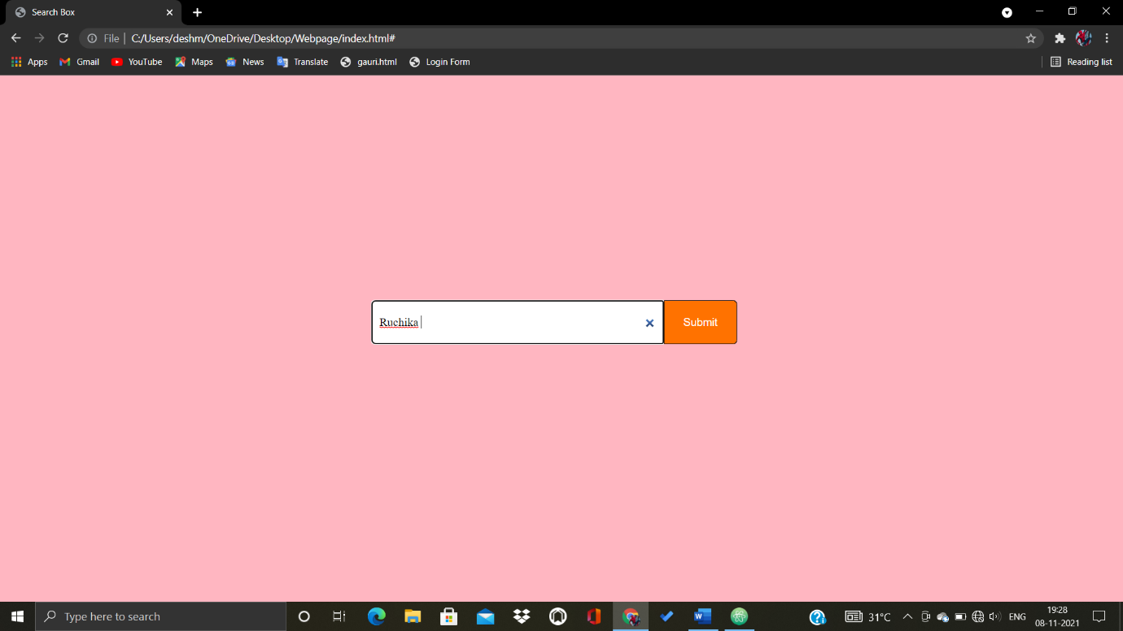**Output:**